# CHAPTER FOUR: DESIGN PHASE

## 4.1 INTRODUCTION

According to Rainer and Cegielski (2011), design phase presents an overview of how the system will deliver a set of technical systems specification which will solve the business problems. System inputs, outputs, user interfaces, database, software, hardware and procedures are the deliverables of the design phase. A blue print for the system’s components integration is also provided by the design phase. The design phase aims at the design, development, deployment and configuration of the new system in conformity with the objectives.

## 4.2 SYSTEM DESIGN

In system design alterations to the current system logical model are implemented until the new system fully represent its blue print (O’Brien and Marakas, 2010). Issues having to do with data storage, security, hardware, software and other things are also discussed and determined in system design. Design activities that bring forth the physical system specifications which fulfill the functional requirements developed in the system analysis phase are also included in system design. The characteristics that delimitate a well-designed system are listed below:

* Functionality

The system ought to be in a position to attain its objectives.

* Usability

The system ought to be useable to the intended users.

* Security

The system must provide privacy and confidentiality for the user.

* Maintainability

Gradual development of the system must be done in order to meet pressure of evolution.

* Reliability

The system must be depended on to cater for user requirements.

### 

### 4.2.1 CONTEXT DIAGRAM

According to Rosenblatt (2014), a context diagram is a top level view of a system that lays bare the scope and boundaries of the system. A context diagram’s main focus is on the data flows between entities that is processes and data stores are not shown. Level one data flow is another name given to a context diagram.



FIGURE 4. 1 CONTEXT DIAGRAM

**KEY**

Entity

System

Data flow

### 4.2.2 DATAFLOW DIAGRAM OF THE PROPOSED SYSTEM.

According to Royce (2010), a dataflow diagram lays bare the relationships between various components in a system. The interconnection between related activities including all interfaces amongst them together with their origins, intended destinations and data stores are revealed by a dataflow diagram. How data input is changed over to output data through a sequence of processes can be interpreted with the aid of Data flow diagrams. Figure 4.2 illustrates the Trade Test Generator data flow.

 FIGURE 4. 2 DATA FLOW DIAGRAM

**KEY**

Entity

Process

Dataflow

Data store

## 4.3 ACHTECTURAL DESIGN

According to Liu (2015), architecture design is a visual representation of how the system’s components interact. One of the deliverables of architecture design is to give a detailed account of the hardware, software and network infrastructure to be employed. Refinement and reexamination of Non-functional requirements identified in the analysis phase will be done to determine the architectural design. The main objective of the architectural design is to determine what parts of the system will be assigned to what parts of the hardware. The Trade Test Generator will use client-server architecture.



FIGURE 4. 3 ACHITECTURE DESIGN

Source: Abbas (2011)

### 4.3.1 CLIENT-SERVER MODEL

According to Liu (2015), workload is partitioned between the client and the server in a client- server model. The client is responsible for the presentation logic while the server is responsible for data access logic. Scalability is an advantage of client-server architecture which entails that decreasing or increasing processing and storage capabilities of the server is easy. Supporting different types of clients and servers is another capability of the client-server model. Most importantly in a client-server model in case of a server failure only those applications requiring the server will fail.



**FIGURE 4. 4 CLIENT/SERVER DIAGRAM**

## Source Andwers (2016)

## 4.4 PHYSICAL DESIGN

Physical design elucidates the system’s technical environment representation which is the arrangement of hardware components (Abbas, 2011). Physical design is explained by the input methods, authentication processes, presentation and manipulation of data. In physical design identified requirements related to the system are decided on. The list of requirements include:

* Input requirements
* Processing requirements
* Output requirements
* Storage requirements
* System regulation and backup recovery

## 4.5 DATABASE DESIGN

According to O’Reily (2002), database design is a process of creating a computerised interrelated collection of stored data that provides user needs within an organisation. For database design the ANSI-SPARC model will be used. The model is a three level abstraction of the external level, conceptual level and internal level.

View 1

View 2

View 3

View n

External level

INTERNAL LEVEL

PHYSICAL STORAGE

CONCEPTUAL LEVEL

FIGURE 4. 5 DATABASE DESIGN ARCHITECTURE

Source: O’Reily (2012)

### 

### 4.5.1 EXTERNAL LEVEL

According to Olah and Muji (2010), the external level is a representation of the user’s view of the database. A detailed account of the database which is pertinent to a particular user is given by the external level. The same data may be presented differently by the external view and it can be made up out of calculated or derived data.

### 4.5.2 CONCEPTUAL LEVEL

Olah and Muji (2010), is of the view that the conceptual level considers a database as a group of entities and seeks to depict the relationship between these entities. Community view is another term that can be used for the conceptual level. Integrity information, data constraints, security, entities, attributes and relationships are pointed out in the community view. The conceptual level also assists the external view as all the data available to a user must be derived from the conceptual level.

### 4.5.3 INTERNAL LEVEL

In the internal level how data is physically represented on the system is included as an essential part (Olah and Muji, 2010). How data is stored in a database in relation with data structures and file organisation is presented by the internal level. The internal level concentrates on data storage space allocation, indexing, description of stored data forms, compression of data and encryption techniques.

### 4.5.4 DATABASE TABLES

Johnson (2015) is of the view that a table is a group of related data contained within a database in a structured format. According to Allen (2010), in relational databases and flat file databases it is composed of columns and rows. The Trade Test Generator data will be stored in tables shown below.

TABLE 4. 1 EXAMINER DETAILS

|  |  |  |
| --- | --- | --- |
| **FIELDNAME** | **DATATYPE** | **DESCRIPTION** |
| Ecnumber | Varchar(15) | Primary key |
| Trade | Varchar(20) | Speciality |
| Class | Varchar(30) | Class 1,2 ,3 |
| Password | Varchar(15) | Login credential |
| Username | Varchar(20) | Login credential |
| Fname | Varchar(50) | First name |
| Lname | Varchar(50) | Last name |
| Fnumber | Varchar(50) | Phone number |
| Email | Varchar(50) | Email address |
| Usertype | Varchar(50) | Chief,normal |

TABLE 4.2 STUDENT DETAILS

|  |  |  |
| --- | --- | --- |
| **FIELDNAME** | **DATATYPE** | **DESCRIPTION** |
| Regnumber | Varchar(15) | Primary key |
| Trade | Varchar(15) | Speciality |
| Class | Varchar(15) | Class,1,2,3 |
| Password | Varchar(15) | Login credential |
| Username | Varchar(20) | Login credential |
| Fname | Varchar(50) | First name |
| Lname | Varchar(50) | Last name |
| Fnumber | Varchar(50) | Phone number |
| Email | Varchar(50) | Email address |
| DOB | Date | Date of birth |
| Gender | Varchar(15) | Male or female |

TABLE 4.3 MULTIPLE CHOICE DETAILS

|  |  |  |
| --- | --- | --- |
| **FIELDNAME** | **DATATYPE** | **DESCRIPTION** |
| Questionnum | Int (15) | Primary key |
| Trade | Varchar(15) | Speciality |
| Class | Varchar(15) | Class,1,2,3 |
| Question | Varchar(500) | Question |
| Chapter | Varchar(20) | Question chapter |
| Weight | Int(2) | Question weight |
| Level | Varchar(50) | Difficulty level |
| Correctanswer | Varchar(50) | Proposed answer |
| ChoiceA | Varchar(500) | Choice A proposed answer |
| ChoiceB | Varchar(500) | Choice B proposed answer |
| ChoiceC | Varchar(500) | Choice C proposed answer |
| Choiced | Varchar(500) | Choice D proposed answer |

TABLE 4.4 SRUCTURED QUESTION DETAILS

|  |  |  |
| --- | --- | --- |
| **FIELDNAME** | **DATATYPE** | **DESCRIPTION** |
| Questionnum | Int (15) | Primary key |
| Trade | Varchar(15) | Speciality |
| Class | Varchar(15) | Class,1,2,3 |
| Question | Varchar(500) | Question |
| Chapter | Varchar(20) | Question chapter |
| Weight | Int(2) | Question weight |
| Level | Varchar(50) | Difficulty level |
| Correctanswer | Varchar(50) | Proposed answer |

TABLE 4. 5 POSTED PAPER DETAILS

|  |  |  |
| --- | --- | --- |
| **FIELDNAME** | **DATATYPE** | **DESCRIPTION** |
| Papernum | Int (15) | Primary key |
| Trade | Varchar(15) | Speciality |
| Class | Varchar(15) | Class,1,2,3 |
| Questions | Varchar(500) | Question |
| Fnmame | Varchar(20) | Firstname |
| Lastname | Varchar(20) | Lastname |
| Level | Varchar(50) | Difficulty level |
| Examdate | Date | Proposed Exam date |
| Dateposted | Date | Posting date |

TABLE 4. 6 STUDENT ANSWER DETAILS

|  |  |  |
| --- | --- | --- |
| **FIELDNAME** | **DATATYPE** | **DESCRIPTION** |
| Regnumber | Varchar(15) | Primary key |
| Trade | Varchar(15) | Speciality |
| Class | Varchar(15) | Class,1,2,3 |
| Questionno | Varchar(500) | Question number |
| Answer | Varchar(20) | Firstname |
| Examdate | Date | Proposed Exam date |

TABLE 4.7 SRUCTURED QUESTION MARKS DETAILS

|  |  |  |
| --- | --- | --- |
| **FIELDNAME** | **DATATYPE** | **DESCRIPTION** |
| Questionnum | Int (15) | Primary key |
| Trade | Varchar(15) | Speciality |
| Class | Varchar(15) | Class,1,2,3 |
| Question | Varchar(500) | Question |
| Chapter | Varchar(20) | Question chapter |
| Weight | Int(2) | Question weight |
| Level | Varchar(50) | Difficulty level |
| Correctanswer | Varchar(50) | Proposed answer |
| Studentreg | Varchar(20) | Student identifier |
| Studentanswer | Varchar(500) | Student answet |
| Marker | Varchar(50) | Marks awarder name |
| Markawarded | Int(2) | Marks awarded |
| Dateposted | Date | Posting date |

TABLE 4.8 RESULTS DETAILS

|  |  |  |
| --- | --- | --- |
| **FIELDNAME** | **DATATYPE** | **DESCRIPTION** |
| Regnumber | Varchar(15) | Primary key |
| Trade | Varchar(15) | Speciality |
| Class | Varchar(15) | Class,1,2,3 |
| Fname | Varchar(50) | First name |
| Lname | Varchar(50) | Last name |
| DOB | Date | Date of birth |
| Gender | Varchar(15) | Male or female |
| Result | Varchar(15) | Pass,Credit,Distinction |

### 4.5.5 ENHANCED ENTITY RELATIONSHIP DIAGRAM

The original entity relationship diagram was expanded in scope to form the enhanced entity relationship diagram. That is it consists all entity relationship diagram concepts but making available more concepts which include super classes and subclasses, completeness constraint, disjoint constraint and subtype discrimination (Bass etal, 2012). An entity relationship model gives description of interrelated objects of interest in a particular domain of knowledge. The ER model employs entity types for the classification of objects of interest and the specification of relationships that can occur among entity instances



**FIGURE 4. 6 ENHANCED ENTITY RELATIONSHIP DIAGRAM**

**KEY**



**4.6 PROGRAM DESIGN**

Sinan (2002) defines program design as the steps taken in concealing crafty designs of classes, functions and modules of the proposed system that will be available to users with the aid of interfaces. Explicitly spelling out all system modules is a necessity to avoid omission of crucial functions. According to Ambler and Lines (2012) UML diagrams such as class, sequence and package diagrams are used to represent system modules and how they interact with each other.

### 4.6.1 PACKAGE DIAGRAM

According to Stafford (2010) a package diagram are several Unified Modelling Language (UML) elements or high level system elements which are logically related and grouped together. Only a UML construct termed as packages is employed for the arranging or organizing into groups the elements of the model such classes or functions. The composition of modules on The Trade Test Generator will be represented on the package diagram along with their dependencies.



**FIGURE 4. 7 PACKAGE DIAGRAM**

### 4.6.2 CLASS DIAGRAM

According to Sinan (2002) a class diagram stages the static structure of a system through the utilization of basic concepts and relationships, apart from the general elements that make up a system. A class diagram in Unified Modelling Language (UML) is a subdivision of structure diagrams which depicts the structure of a system through exhibiting the system's classes, attributes, operations and the relationships between objects. An overview of the Trade Test Generator system will be illustrated with the aid of its classes and the relationships involved in the class diagram below.

## 

**FIGURE 4. 8 CLASS DIAGRAM**

### 4.6.3 SEQUENCE DIAGRAM

Allen (2010) is of the view that a sequence diagram in Unified Modelling Language is a form of a fundamental interaction that shows how processes operates with one another and the order in which they are performed. Sequence diagram are commonly used for both analysis and design purposes as they model in a visual manner the flow of logic within the system.

## 

**FIGURE 4. 9 SEQUENCE DIAGRAM**

## 4.7 INTERFACE DESIGN

Andwers (2015) defines interface design as the modelling of a platform that will represent the system’s face for the interaction and communication with users that is they are a medium of user and system interaction. Interface design includes graphic user interfaces for software in order to maximise usability and user experience. In order to maximize efficiency and system responsiveness throughout the user’s interaction with the system interfaces should be well designed. Allowing a user to perform any mandatory task and the ability to bring about a detailed output on the basis of inputs provided are the characteristics of a well-structured interface. Design of user interface, the nature of main menu, menu designs input, and outputs in the system, ways of accepting data and producing information are the main focus.

### 4.7.1 MENU DESIGN

Menu design focuses on designing a group of options to be exhibited to the user in order to assist the user to execute a required task. To redirect user to a particular form or function links on navigation bars and drop-downs will be used to list sets of options.

#### **4.7.1.1 MAIN MENU**

A main menu is an intermediate platform for all the users after or before they are logged in order to acquaint with system options.

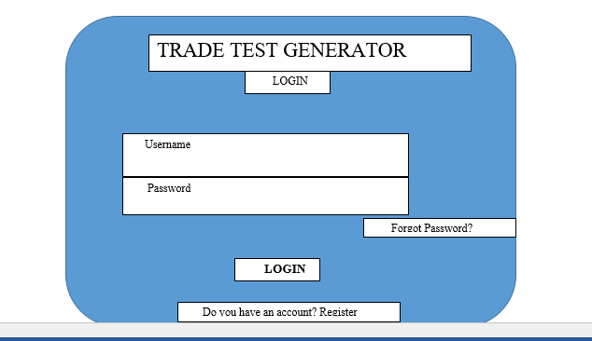

**FIGURE 4. 10 MAIN MENU INTERFACE**

### 4.7.2 SUB MENUS

Sub menus gives assistance in cleaning up a busy main menu that is a menu that is incorporated in another menu. In most cases drop-downs are employed in the design of sub menus in form of an arrows pointing to the right at the edge of a menu item.

**Administrator Homepage design**

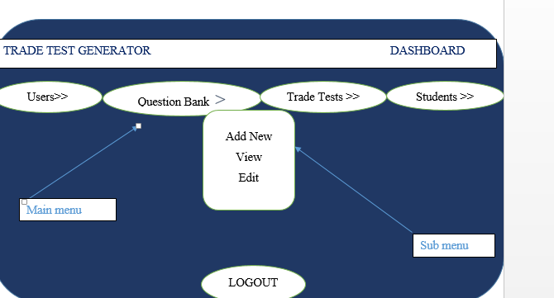

**FIGURE 4. 11 ADMINISTRATOR HOME**

**Examiner Homepage design**

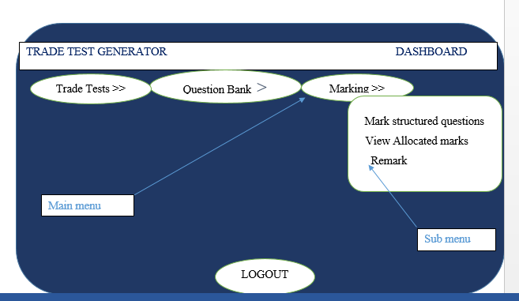

**FIGURE 4.12 EXAMINERS HOMEPAGE**

**Chief Examiner Homepage Design**

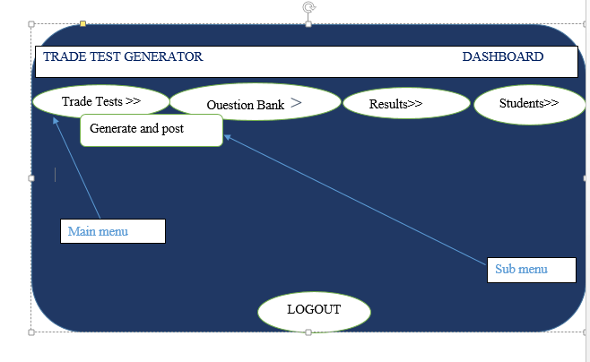

**FIGURE 4.13 CHIEF EXAMINER HOMEPAGE**

**Student Homepage Design**

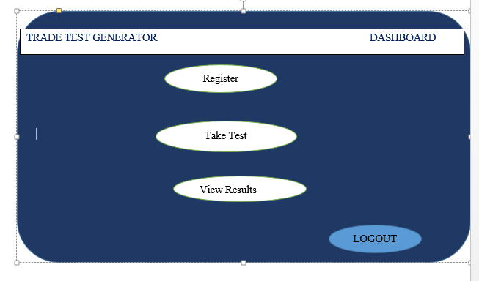

**FIGURE 4.14 STUDENT HOMEPAGE**

**Input Design**

Stafford et al (2010) defines input Design as a process of changing over user’s opinion of the input into a computer-based system .It includes designing input forms for users to be utilise for data input into the system. According to Boehm (2011) input design conceals the complexity of the system through implementing a user friendly interface. Input design also facilitates design input processes that guarantees data accuracy and timeliness.

**Add multiple choice question form**

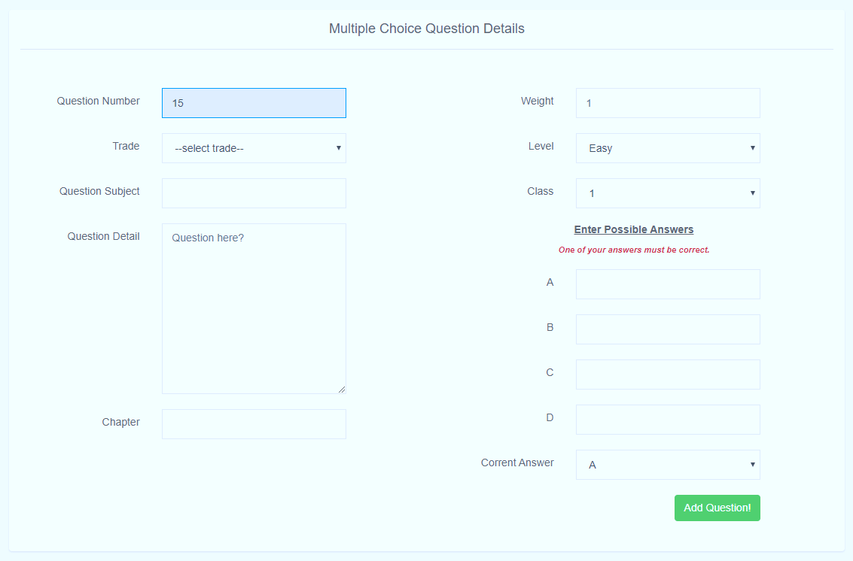

**FIGURE 4.15 ADD MUITIPLE CHOICE QUESTION FORM**

**Add structured questions form**

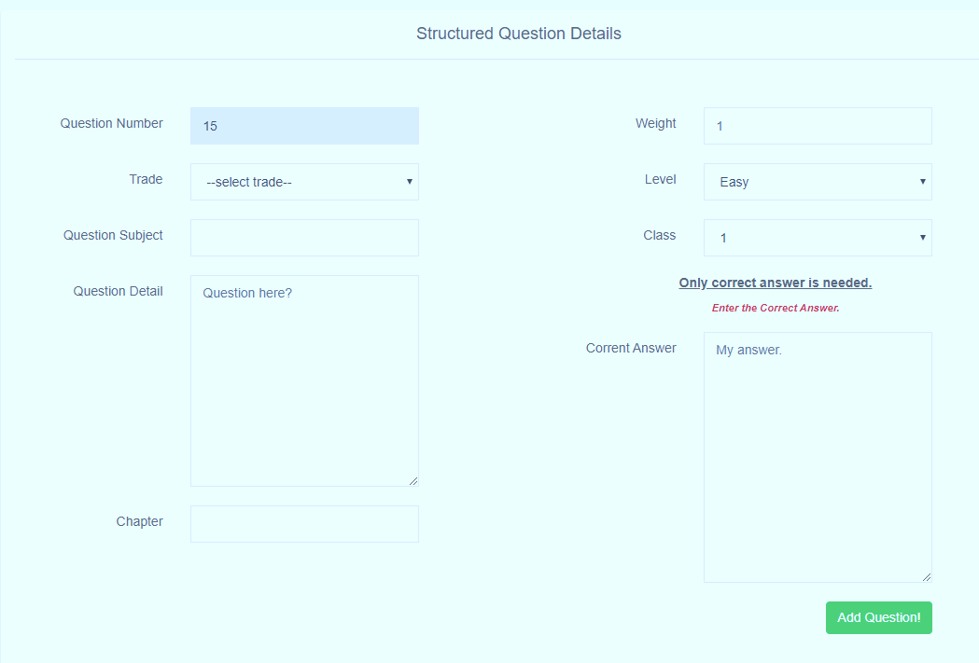

**FIGURE 4.16 ADD STRUCTURED QUESTIONS FORM**

**Output Design**

According to Stafford et al (2010) an output design is compelled to fulfill its intended function and do away with the production of undesirable output, conform to user requirements and present appropriate output. Facilitating timely decision making through making output available to the intended person in an appropriate format is the output forms objective. The following Figure illustrates the output format of the Trade Test.

**Trade Test output form**

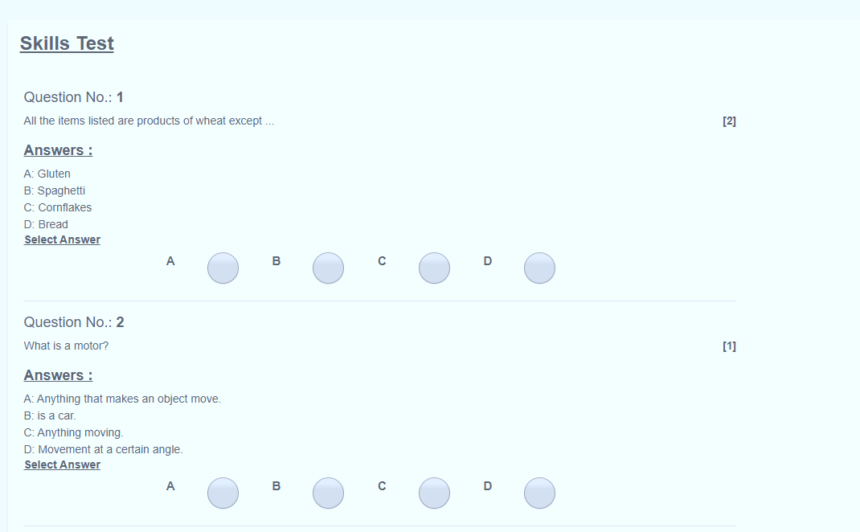

**FIGURE 4.17 TRADE TEST OUTPUT FORM**

**4.8 CONCLUSION**

This chapter outlined and explained all the designs included in system design scope which includes architectural design, physical design, database design, program design and interface design. The designs will be implemented in the actual coding of the proposed system providing guidelines for developers eliminating the chance of developing from the head. The next chapter focuses on developing the system, testing until implementation and also excogitating change over strategies.